MAT² Employer Reservation Form
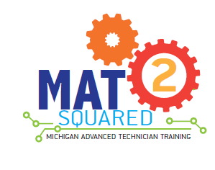
Fall 2019

Please complete the information below to reserve space for your company in an upcoming MAT² cohort.
Company Name: | Click here to enter text.
Primary Contact: | Click here to enter text.
Title: | Click here to enter text.
Mailing Address: | Click here to enter text.
E-mail | Click here to enter text.
Office Phone | Click here to enter text.
Cell Phone: | Click here to enter text.
Occupation  (check one): | Baker College of Cadillac, and Henry Ford College | ☐ | Mechatronics |  | # of students
 | Henry Ford College, and Kalamazoo Valley Community College | ☐ | CNC |  | # of students
Trainee’s work location (please enter full address, if different from the address above) where student(s) will be completing work assignments: |  | Click here to enter text.
*Preferred location (college) for classroom training: |  | Click here to enter text.

Company Mentor/Instructor Information:
The person who will work with the student. Complete only if different than the Primary Contact.
Name:
Title:
Address:
Phone:
Cell:
Email:
This reservation is not a binding agreement; it allows the MAT² program administration to reserve trainee slots for your company. In order to help ensure access to more candidates, please post your MAT² Technician job as soon as possible on mitalent.org.

* This reservation does not guarantee these occupations will be offered in the timeframe or locations requested.

Signature: _________________________Date: _____________________________

Upon completion, please e-mail this page to mat2@michigan.gov. Thank you!

